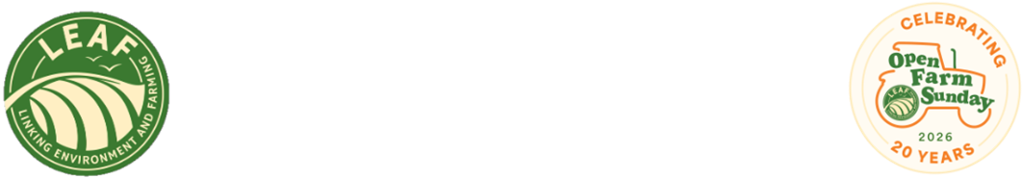

FOR IMMEDIATE RELEASE
8th June 2026

Families across Britain celebrate 20 years of Open Farm Sunday

Hundreds of thousands of people visited working farms across England, Scotland and Wales this weekend as Open Farm Sunday celebrated its 20th anniversary.
From meeting livestock, tractor rides, exploring crops to joining farm walks, nature activities and family-friendly demonstrations, visitors of all ages had the chance to step behind the farm gate and learn more about where their food comes from.
Managed by LEAF (Linking Environment And Farming), Open Farm Sunday has become one of British farming’s biggest public engagement success stories since it launched in 2006.
This year, 200,000 visitors were welcomed onto participating farms, giving them the opportunity to meet farmers and see food production, nature and the countryside first-hand. A total of 283 farmers hosted events, up by 4.5% from 2025, with around a quarter taking part as first-time hosts.
Open Farm Sunday manager Annabel Shackleton says the milestone year showed how much people value the opportunity to connect with farming.
“Open Farm Sunday has always been about bringing farmers and families closer together,” she says.
“This year’s 20th anniversary has been a wonderful celebration of farming, food and community. We are hugely grateful to every host, volunteer, sponsor and supporter who helped make the day possible.
“For many visitors Open Farm Sunday may be their first time on a working farm. Being able to see crops growing, meet animals, ask questions directly helps create a connection that can last long after the day itself.”
New research commissioned by LEAF ahead of this year’s event highlights the value people place on British food production and farming with nature.
The survey of more than 2,000 people found that 89% agree that protecting nature on farms, including healthy soils, flood defences and biodiversity, is essential for long-term food production.
Mrs Shackleton adds: “These findings show that people care deeply about how their food is produced and want to understand more about the role farms play in looking after the countryside.
“Open Farm Sunday creates opportunities for positive, open conversations, and that has never been more important.”
Since 2006, Open Farm Sunday has welcomed more than 3.5 million people onto farms, helping visitors meet the people who produce their food and learn more about the role farming plays in the environment, the economy and rural communities.
Cambridgeshire farmer Michael Sly MBE, who runs the biggest single Open Farm Sunday event and has hosted more than 120,000 visitors over the past 20 years, says the day has become a major community occasion.
“We started with 12 people attending in 2006 and now host around 12,000 visitors. Over the years, it has become a community event that the whole village has really got behind,” says Mr Sly.
“There is so much we can learn from each other, and Open Farm Sunday highlights that on every level.”
LEAF has thanked the farmers, volunteers, sponsors and wider industry supporters who helped host events across Britain, as well as the hundreds of thousands of visitors who attended.
Next year’s Open Farm Sunday will take place on 13 June 2027.
ENDS
NOTES TO EDITOR
For further information, please contact the Open Farm Sunday Press Office at Pinstone:
Becky George – b.george@pinstone.co.uk Phone: 01568 313 122 / 07775 561412
Keep up to date with all the Open Farm Sunday news and join in the online conversations using #OFS26:
  - X: @OpenFarmSunday
  - Facebook: @OpenFarmSunday
  - Instagram: @OpenFarmSunday
- Open Farm Sunday is managed by LEAF (Linking Environment And Farming) – the charity that promotes and supports more sustainable farming to create a resilient food and farming system for future generations. LEAF is a registered charity no: 1045781 www.leaf.eco
- With thanks to our Open Farm Sunday principal sponsors: AHDB, Arla Foods, BASF, Co-op, Defra, Frontier Agriculture, John Deere, LEAF Marque, Lidl, M&S, McDonald’s, NFU, Sainsbury’s, Tesco, and Waitrose.
- Open Farm Sunday 2026 will take place on 7th June 2026. Find a farm to visit at: www.farmsunday.org
- To contact the Open Farm Sunday team direct:
Email: OpenFarmSunday@leaf.eco Tel: 02476 413911 Mob: 07912 463151

