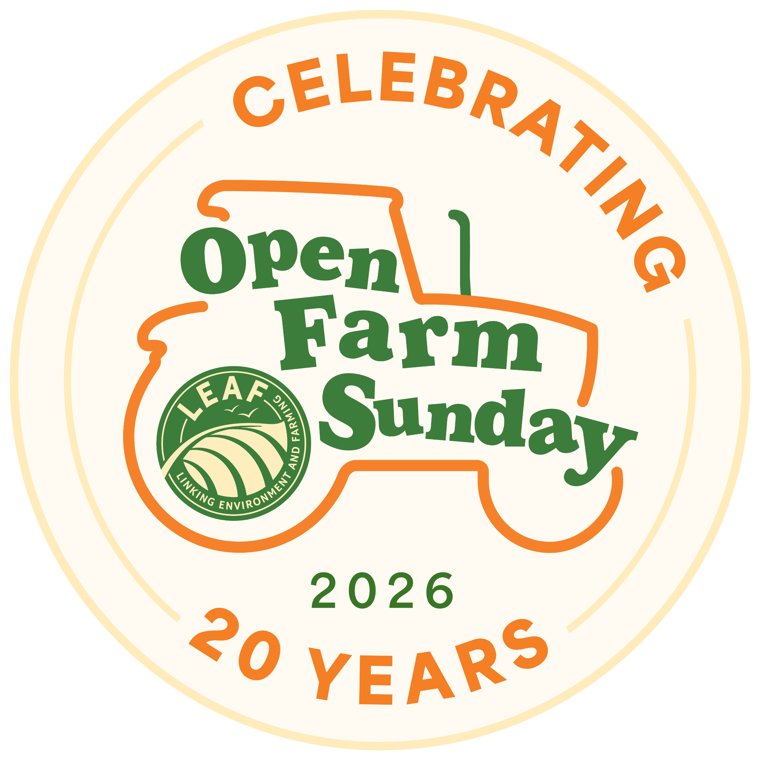
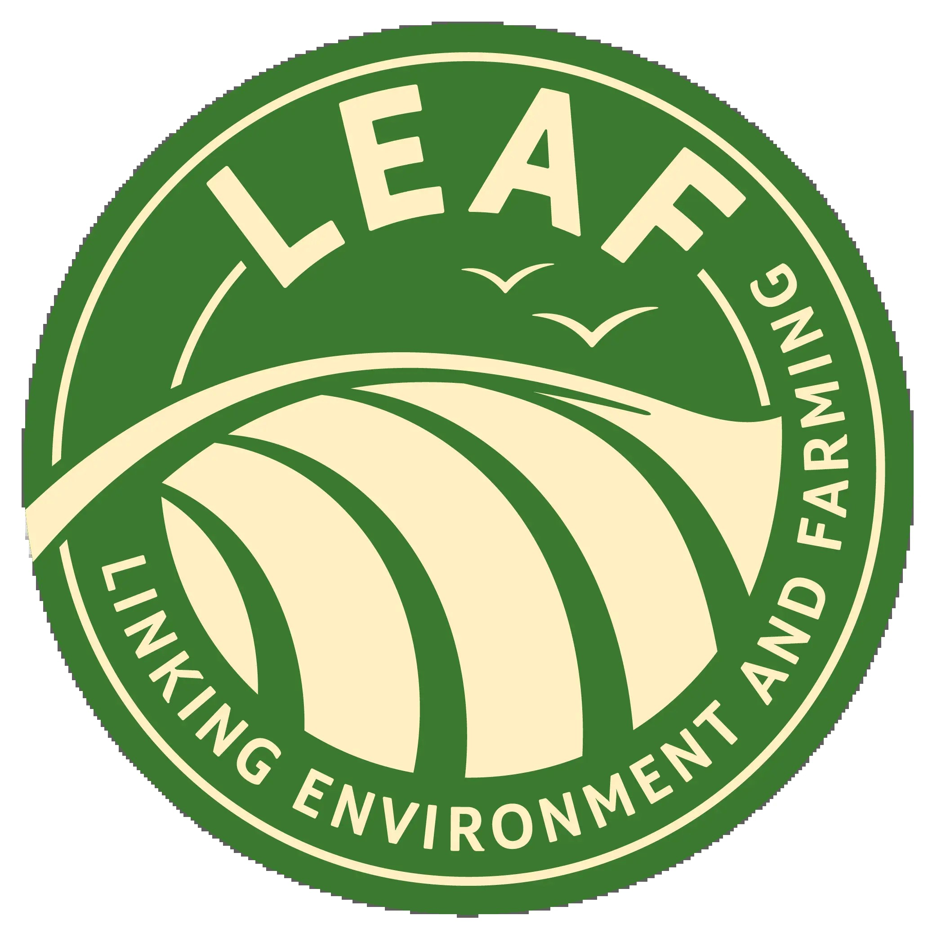

FOR IMMEDIATE RELEASE
1st June 2026

Families invited to see farming with nature in action this

Open Farm Sunday

Ahead of Open Farm Sunday’s 20 anniversary, new research by organisers, LEAF (Linking Environment And Farming), reveals deep-rooted public support for farmers who produce food while protecting nature.
Families across the country have the chance to visit one of over 250 farms taking part in Open Farm Sunday on 7 June, to discover the world of farming, make new connections and explore the vital links between food production, farming and nature.
The survey of more than 2,000 people found that 93% believe it is important for the UK to maintain a strong level of food production capacity in an increasingly uncertain world.
At the same time, 89% agreed that protecting nature on farms, including healthy soils, flood defenses and biodiversity, is essential for long-term food production, while 71% said farmers should focus on producing food while also protecting nature.
The findings highlight the importance of helping people see, first-hand, what sustainable farming looks like beyond the supermarket shelf. On Open Farm Sunday, farms of different sizes and sectors open their gates, giving visitors the chance to ask questions and discover how wildlife, soils, water, technology and food production are all connected.
Annabel Shackleton, Open Farm Sunday Event Manager, said: “Open Farm Sunday is a wonderful day of discovery. Families can immerse themselves in a world they don’t usually see.
“It’s an opportunity to see sustainable farming in action, not as an idea on a label, but as something real, practical and happening every day. This research shows people care deeply about food security and about nature, and farmers are working hard to deliver both.
“For 20 years, Open Farm Sunday has helped build trust and connection between the public and farming. This anniversary year is a wonderful opportunity for children and adults alike to engage with farming in an interactive, fun and inspiring way while seeing how their everyday food choices can help support a more sustainable future.”
Open Farm Sunday is one of the farming industry’s leading public engagement programmes. It offers a unique opportunity for visitors to meet a farmer, get up close to machinery, livestock and the crops they produce, and experience the care, integrity, pride and innovation that goes into producing British food.
This year’s campaign encourages people to turn food labels into lived experiences by visiting a farm, meeting farming champions and discovering how nature and innovation work together.
Find details of local farms to visit on the Open Farm Sunday website.
ENDS
NOTES TO EDITOR
For further information, please contact the Open Farm Sunday Press Office at Pinstone:
Becky George – b.george@pinstone.co.uk Phone: 01568 313 122 / 07775 561412
Keep up to date with all the Open Farm Sunday news and join in the online conversations using #OFS26:
  - X: @OpenFarmSunday
  - Facebook: @OpenFarmSunday
  - Instagram: @OpenFarmSunday
- Open Farm Sunday is managed by LEAF (Linking Environment And Farming) – the charity that promotes and supports more sustainable farming to create a resilient food and farming system for future generations. LEAF is a registered charity no: 1045781 www.leaf.eco
- With thanks to our Open Farm Sunday principal sponsors: AHDB, Arla Foods, BASF, Co-op, Defra, Frontier Agriculture, John Deere, LEAF Marque, Lidl, M&S, McDonald’s, NFU, Sainsbury’s, Tesco, and Waitrose.
- Open Farm Sunday 2026 will take place on 7th June 2026. Find a farm to visit at: www.farmsunday.org
- To contact the Open Farm Sunday team direct:
Email: OpenFarmSunday@leaf.eco Tel: 02476 413911 Mob: 07912 463151

