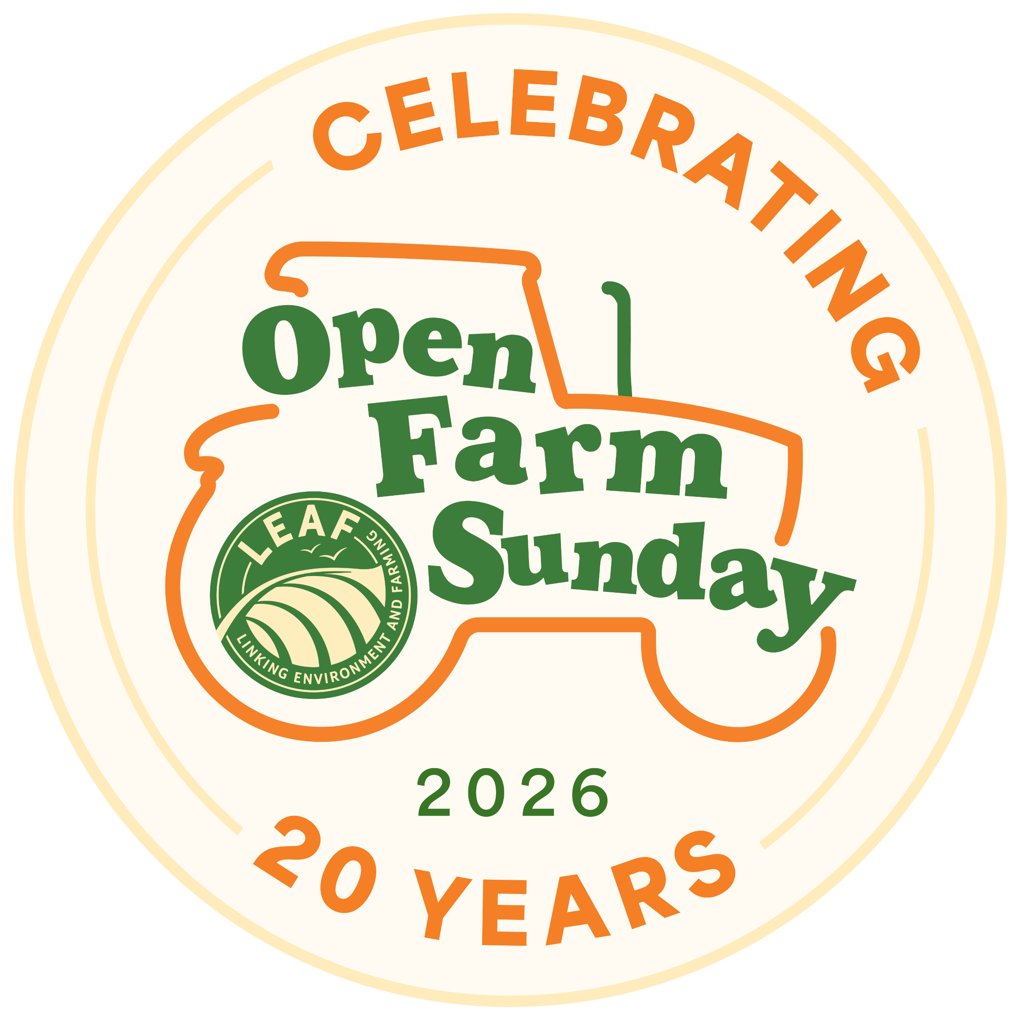
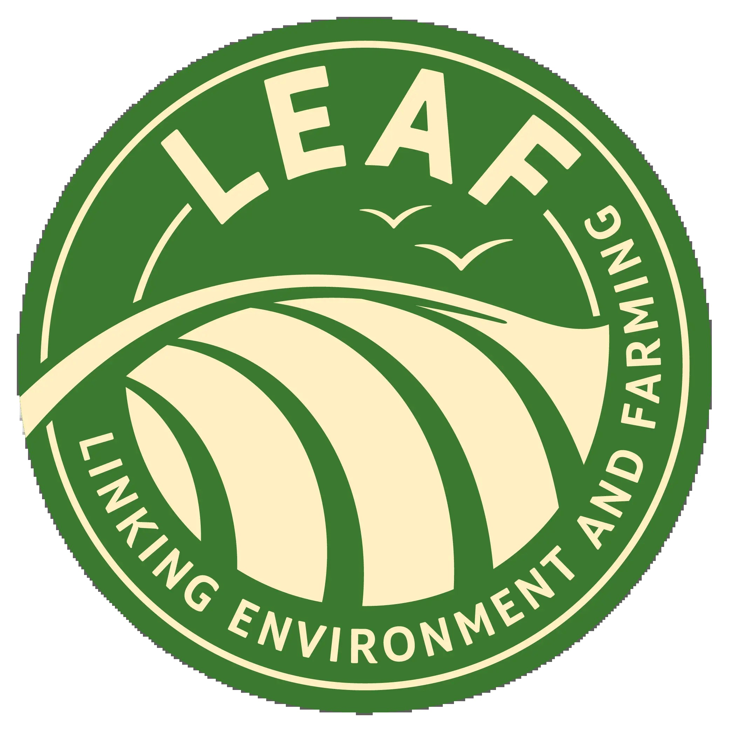

FOR IMMEDIATE RELEASE
1st June 2026

Latest LEAF research:
Public backs farming that delivers food security and nature gains ahead of Open Farm Sunday’s 20th anniversary
- New research from LEAF shows 93% of the public believe it is important for the UK to maintain strong levels of domestic food production capacity
- With the war in Iran causing fuel and fertiliser prices to rise, farmers are under more pressure than ever and this research reveals significant support for the work they do
- Coming ahead of Open Farm Sunday on June 7, the survey of more than 2,000 people found the public wants farmers to produce food and protect nature at the same time
- 89% agreed that protecting nature on farms, including healthy soils, flood defenses and biodiversity, is essential for long-term food production
- Recent government suggestions that a price cap at retail level on staples such as bread, milk and eggs could be a way to solve food price inflation has once again put domestic food production front and centre of wider social and economic debates
- Celebrating its 20th anniversary, Open Farm Sunday has welcomed more than 3 million onto farms over the past 20 years

New consumer research from LEAF (Linking Environment And Farming) shows overwhelming public support for UK farming systems that deliver both food production and environmental benefits, underlining the importance of connecting consumers with farmers ahead of this year’s Open Farm Sunday.
The survey of more than 2,000 people found that 93% believe it is important for the UK to maintain a strong level of food production capacity in an increasingly uncertain world.
At the same time, 89% agreed that protecting nature on farms, including healthy soils, flood defences and biodiversity, is essential for long-term food production, while 71% said farmers should focus on producing food while also protecting nature.
The findings also reveal strong backing for investment in sustainable farming, with 68% wanting to see more money invested into farming systems that help secure future UK food supplies while improving environmental outcomes such as healthy soils, clean water and wildlife habitats.
In addition, 70% of respondents said they would be either ‘very willing’ or ‘somewhat willing’ to pay a little more for food produced in ways that support better outcomes for nature.
The results come as farmers across the country prepare to welcome the public onto their farms for Open Farm Sunday’s 20th anniversary on 7 June, 2026. The annual event offers visitors the chance to explore beyond the farm gate, meet the people producing their food and learn more about how modern farming works alongside nature.
David Webster, chief executive of LEAF, said: “These results clearly show that people do not see food production and nature-friendly farming as competing priorities.
“Consumers recognise that resilient food systems depend on healthy soils, thriving biodiversity and sustainable farming practices working hand-in-hand with productive agriculture. Supporting both together is essential for the long-term future of farming, food security and the environment.
“Open Farm Sunday is therefore the sector’s opportunity to articulate the value of agriculture to a wider audience. It brings people face-to-face with the farmers who feed them, giving them the chance to understand why the farms in their community matter, not only in terms of food production but also environmental good and agriculture’s wider input into society.”
Open Farm Sunday gives consumers the opportunity to see first-hand the care, integrity, pride and innovation that goes into producing British food, helping them make informed food choices with greater confidence.
The event remains one of the farming industry’s most important opportunities to strengthen public understanding of agriculture and celebrate the vital role farmers play in feeding the nation while caring for the countryside.
ENDS
NOTES TO EDITOR
For further information, please contact the Open Farm Sunday Press Office at Pinstone:
Becky George – b.george@pinstone.co.uk Phone: 01568 313 122 / 07775 561412
Keep up to date with all the Open Farm Sunday news and join in the online conversations using #OFS26:
  - X: @OpenFarmSunday
  - Facebook: @OpenFarmSunday
  - Instagram: @OpenFarmSunday
- Open Farm Sunday is managed by LEAF (Linking Environment And Farming) – the charity that promotes and supports more sustainable farming to create a resilient food and farming system for future generations. LEAF is a registered charity no: 1045781 www.leaf.eco
- With thanks to our Open Farm Sunday principal sponsors: AHDB, Arla Foods, BASF, Co-op, Defra, Frontier Agriculture, John Deere, LEAF Marque, Lidl, M&S, McDonald’s, NFU, Sainsbury’s, Tesco, and Waitrose.
- Open Farm Sunday 2026 will take place on 7th June 2026. Find a farm to visit at: www.farmsunday.org
- To contact the Open Farm Sunday team direct:
Email: OpenFarmSunday@leaf.eco Tel: 02476 413911 Mob: 07912 463151

